Evan Tilley

elt2141

Competitor Research – Mushroom Website

[www.mushroom.world](http://www.mushroom.world) is a competitor that provides users with a database of mushrooms to learn about.

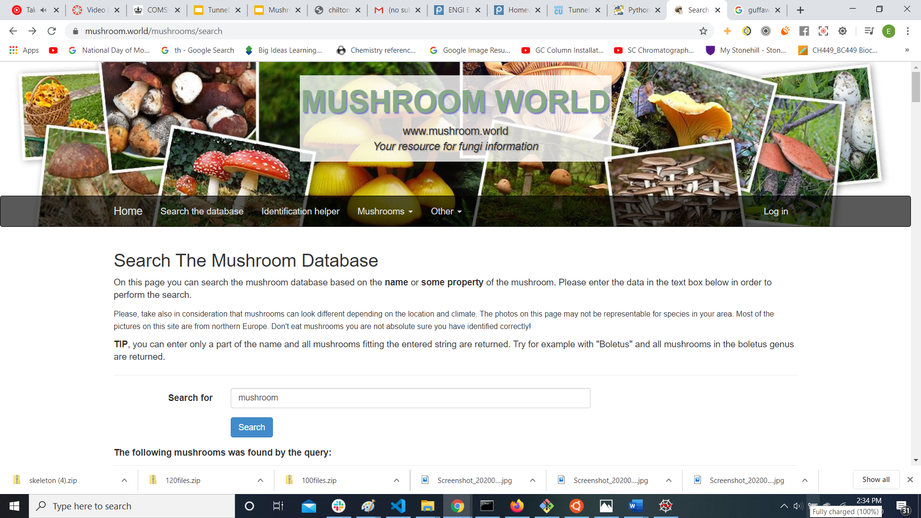

I like that this website has very detailed information on each mushroom, so users will learn a lot about the various species of mushrooms on the site. However, the site is not very interactive and doesn’t present users with the opportunity to test their knowledge. My site will be more interactive and user friendly.